Carrier Accessorial Fee Data Entry and Tolerance Validation Rules v-8.0

Watch a Video! 

The Carrier Accessorial Data Entry Fee Tolerance is used to determine when a fee can be auto-approved by the system. Tolerance levels do not prevent carriers from entering fees above or below the configured range.

# Rules

1. All carrier entered accessorial fees are flat rate charges.
   1. Web Portal: carriers are asked to enter accessorial fees by order number. In v-8.0 Carriers are asked to perform any allocation manually if fees are to be applied across multiple orders (like fuel). In v-8.1 the allocation rules for EDI will also be available for Web Portal (see b).
   2. EDI: Available in v-8.1. Fees may be entered for Load, Order Number or Stop Number. The TMS system will perform allocations as follows:
      1. If Order Number selected no allocation.
      2. If Stop Number selected allocated by weight for each delivery address with the same stop number.
      3. If Load Allocation the selected fee will be allocated by weight across all orders.
      4. Notes:
         1. Load Allocation is the only way pickup fees may be applied to a load.
         2. Multi-pick inbound fee allocation for pickup locations is not supported
         3. All pickup fees must be allocated for the load.
2. Each Legal Entity has separate accessorial fee tolerance settings
   1. Legal Entities are linked to TMS companies via the Legal Entity key on the company maintenance page.
   2. One company is assigned to each Legal Entity as the master company (or home office). This is maintained via the new Legal Entity maintenance page in TMS 365.
3. Accessorial Fee Tolerance Settings are maintained via the new Carrier Accessorial Fee Maintenance page in TMS 365.
4. Each Fee for each Carrier has individual settings assigned to each Legal Entity.
   1. Flat Rate Low Value: minimum dollar value allowed; typically zero.
   2. Flat Rate High Value: maximum dollar value allowed.
   3. Expected Cost: Previously call the Average Value. The Expected Cost is only used by the percentage tolerance calculations.
   4. Lowest Percentage Factor: based on a pre-determined Expected Cost. The lowest percentage below the Expected Cost that is allowed, typically this is 100% which will evaluate to a minimum cost of zero dollars.
   5. Highest Percentage Factor: base on the Expected Cost, The highest percentage above the Expected Cost that is allowed.
5. Calculation Rules:
   1. If the Expected Cost is zero the system will use the Flat Rate values to determine if the Cost falls inside the Flat Rate Tolerances.
   2. If the Expected Cost is non-zero the system will use the Percentage Factors to determine if the Cost falls inside the Percentage Tolerances.
6. Flat Rate Formula:
   1. If Cost falls below the *Flat Rate Low Value* the fee cannot be auto-approved.
   2. If the Cost exceeds the *Flat Rate High Value* the fee cannot be auto-approved.
7. Low Percentage Factor Formula: If the Cost falls below the *Calculated Low Value* based on the *Low Percentage Factor* the fee cannot be auto-approved.
   1. If *Low Percentage Factor* is zero the *Calculated Low Value* is equal to the *Expected Cost*; the fee cannot be auto-approved if it falls below the *Expected Cost*.
   2. If *Low Percentage Factor* is greater than zero we apply the *Low Percentage Factor* to the *Expected Cost:*  where the *Calculated Low Value* equals the difference between the *Expected Cost* and the product of the *Expected Cost* and the *Low Percentage Factor.*
   3. Example: In this example the *Lowest Cost Allowed* is $112.50
      1. Expected Cost = 150, Low Percentage Factor = 25%.
      2. Calculated Low Value = 150 - (150 * 0.25)
      3. or $112.50 = $150 - $37.50
8. High Percentage Factor Formula: If the Cost exceeds the *Calculated High Value* based on the *High Percentage Factor* the fee cannot be auto-approved.
   1. If the *High Percentage Factor* equals zero the *Calculated High Value* is equal to the *Expected Cost;* the fee cannot be auto-approved if it exceeds the *Expected Cost*.
   2. If the *High Percentage Factor* is greater than zero we apply the *High Percentage Factor* to the *Expected Cost*: where the *Calculated High Value* equals the sum of the *Expected Cost* and the product of the *Expected Cost* and the *High Percentage Factor*.
   3. Example: In this example the *Highest Cost Allowed* is $187.50
      1. Expected Cost = 150, High Percentage Factor = 25%.
      2. Calculated High Value = 150 + (150 * 0.25)
      3. or $187.50 = $150 + $37.50

Examples

**1) Using Flat Rate example:**Enter in dollar low and high range. Low = $0 High = $195

The fee entered by the carrier must fall between this range.  
*Percentage values and average value all must be zero and not being applied.*

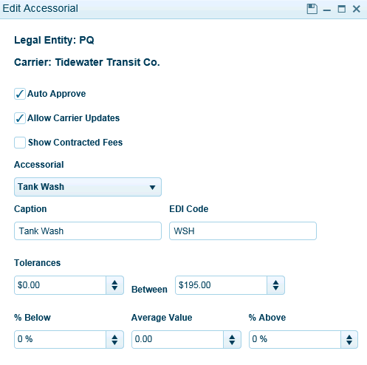  
 **2) Using Percentage Rate Example:***Dollar value ranges are equal to zero and not being applied.  
Percentage values are set to 100% below Expected Cost value and 30% above (.30 x 150) Expected Average value $150 (zero).*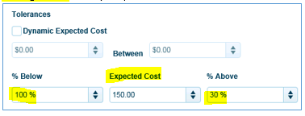  
**3) Dynamic Expected Cost**  
This is used when you want to allow for variability in the fee entry by the carrier. When checked on, you enter in the % Below value (100% to equal zero) and % Above value ranges. Expected cost remains blank. **For example**: Let’s say you configured fuel to use *Dynamic Expected Cost*. If your settings were 100% below value and 10% high value and the actual fuel cost for a given load was $225.00. This configuration will allow for $0 on the below value and will allow up to $247.50 on the high value.

